ServletContext Interface->

An object of ServletContext is created by the web container at time of deploying the project.

This object can be used to get configuration information from web.xml file.

There is only one ServletContext object per web application.

**SIMILLAR TO->GLOBAL VARIABLE**

### **Advantage of ServletContext**

**Easy to maintain** if any information is shared to all the servlet, it is better to make it available for all the servlet. We provide this information from the web.xml file, so if the information is changed, we don't need to modify the servlet. Thus it removes maintenance problem.

### **Usage of ServletContext Interface**

There can be a lot of usage of ServletContext object. Some of them are as follows:

1. The object of ServletContext provides an interface between the container and servlet.
2. The ServletContext object can be used to get configuration information from the web.xml file.
3. The ServletContext object can be used to set, get or remove attribute from the web.xml file.
4. The ServletContext object can be used to provide inter-application communication.

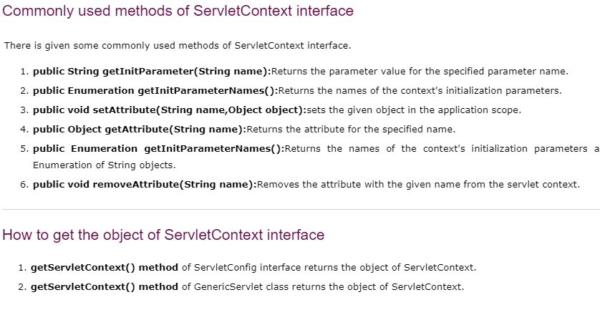

**Example->**

**//creating ServletContext object**

**ServletContext context=getServletContext();**

**//Getting the value of the initialization parameter and printing it**

**String driverName=context.getInitParameter("dname");**

**pw.println("driver name is="+driverName);**

